# Introduction to Particle Accelerators

# TUTORIAL 3 QUESTIONS & ANSWERS

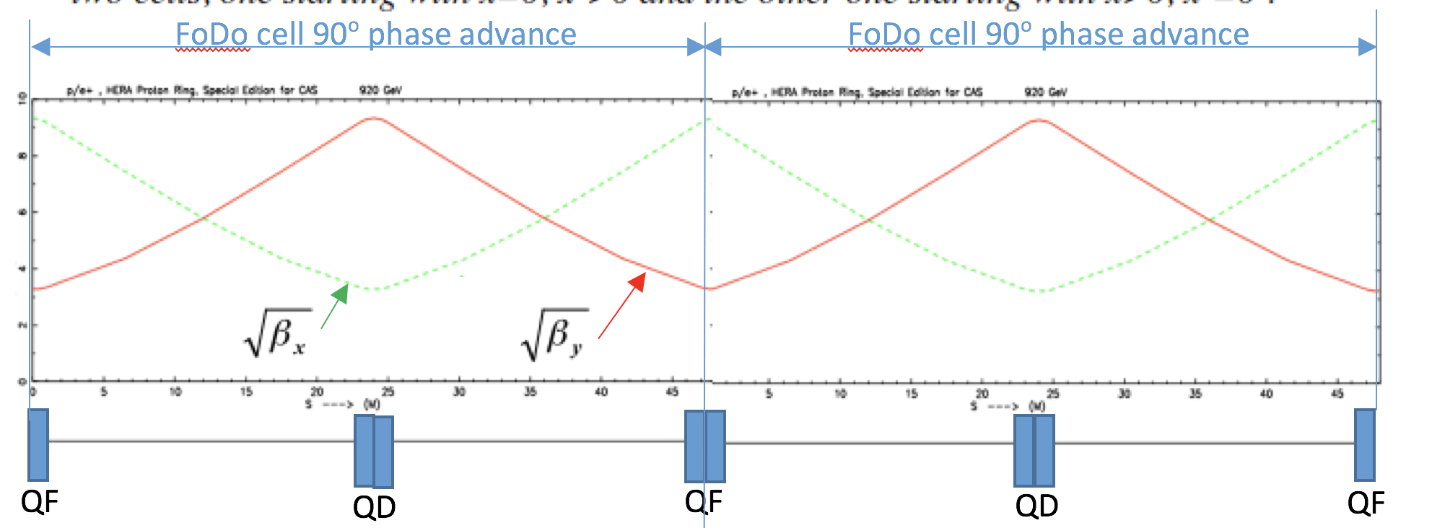

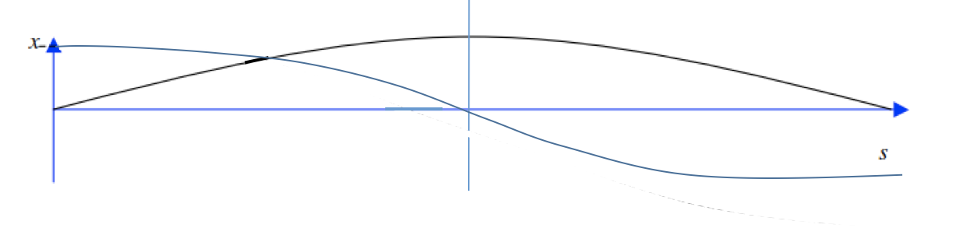

## **2 Phase space ellipses**

Assume somewhere in the storage ring there is a position where α = 0.

Where would such a situation occur typically?

α=0 means that the beta function has an extreme value: maximum or minimum.

Such a situation occurs in general in the center of quadrupoles (in a pure FoDo or similar structure this is always the case) or in the middle of a beam waist.

How will the phase space ellipse look like?

Depending on the beta (maximum or minimum) the ellipse will be flat in the horizontal plane or upright.

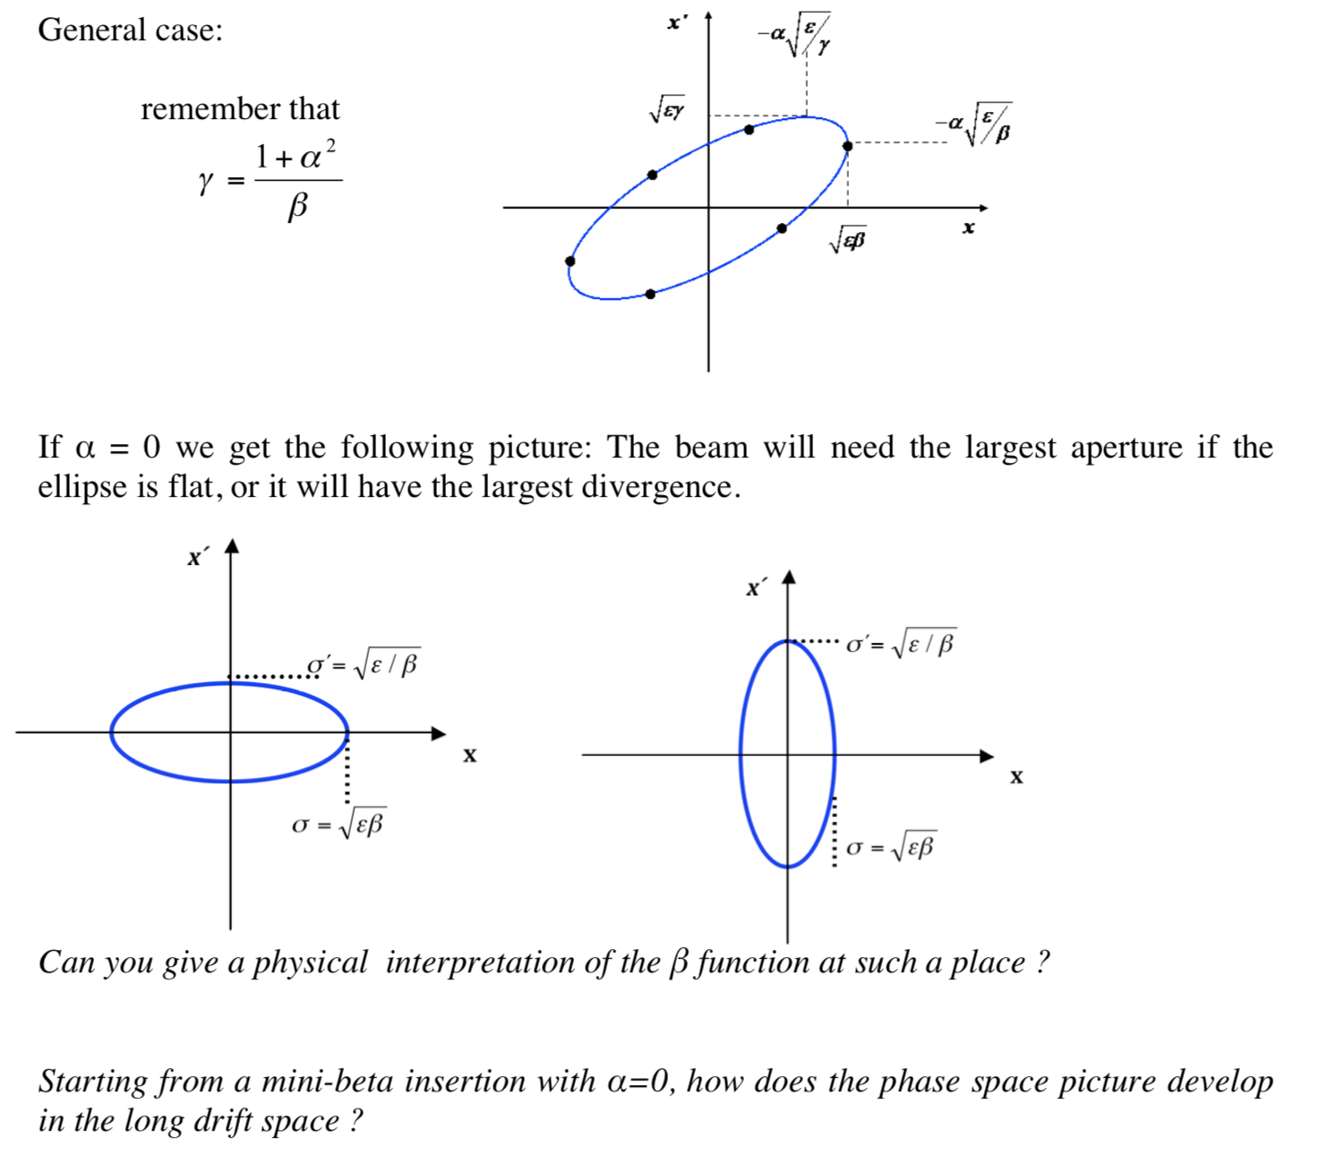

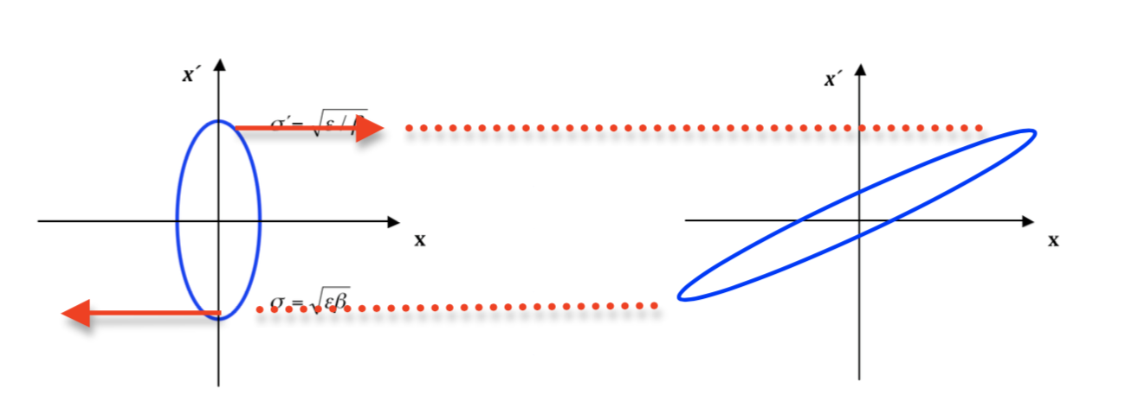

In a drift space x’1 = x’2 since there are no magnets, so the ellipse evolves keeping constant the maximum x’

## **3 Apertures and beam envelopes at LHC**

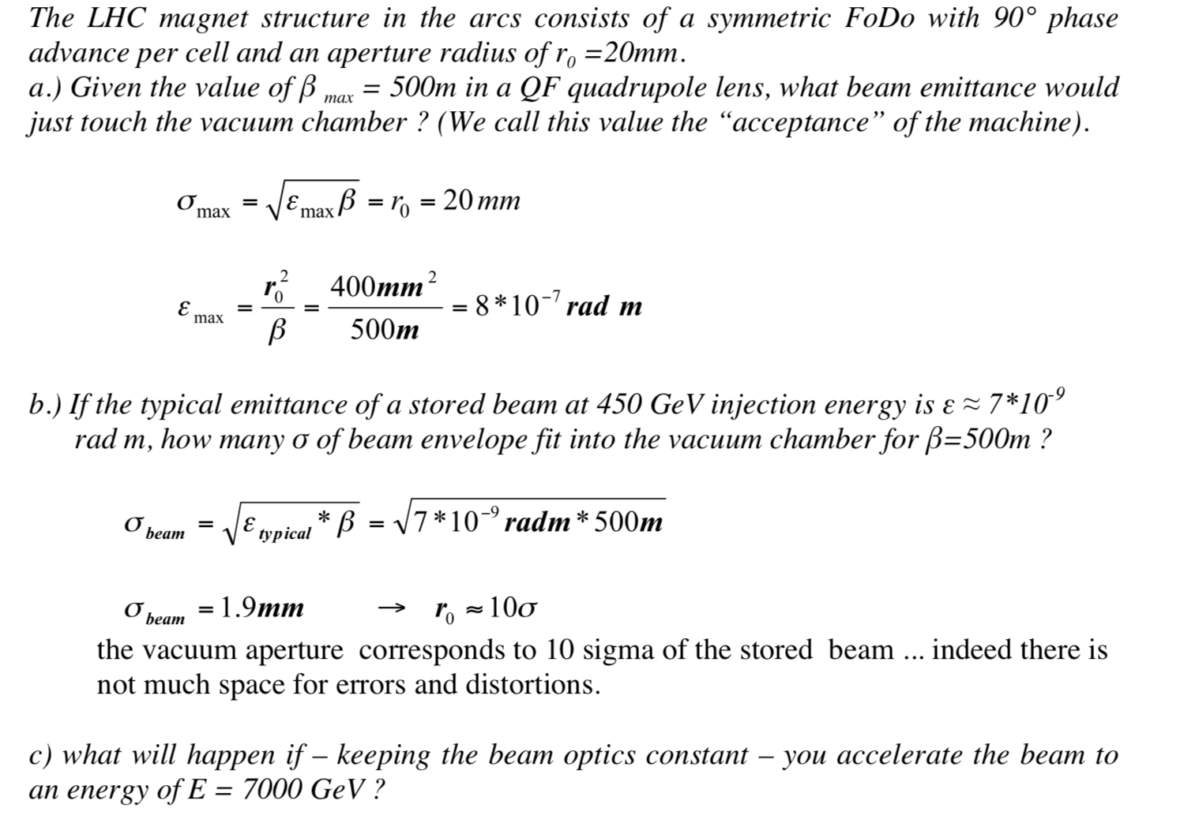

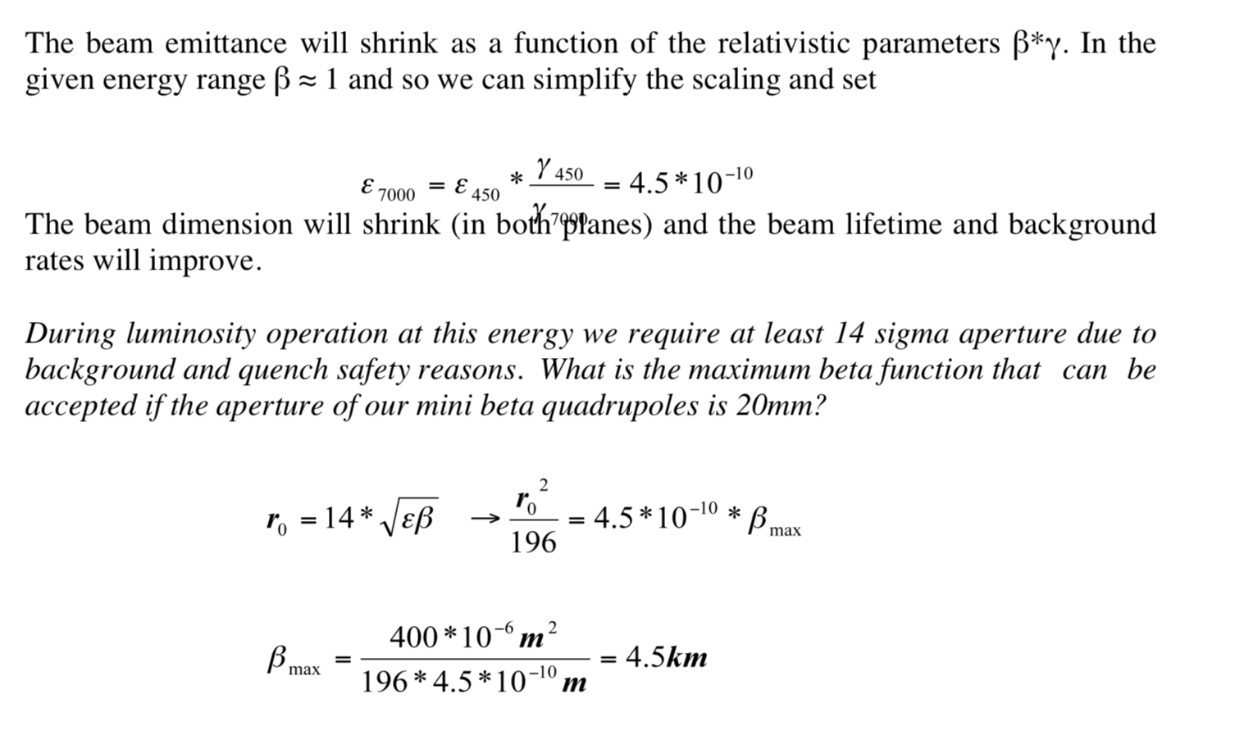

## **4 Apertures and beam envelopes at HERA**

