# Introduction to Particle Accelerators

# TUTORIAL 3 QUESTIONS

## **1 Explain with your own words …**

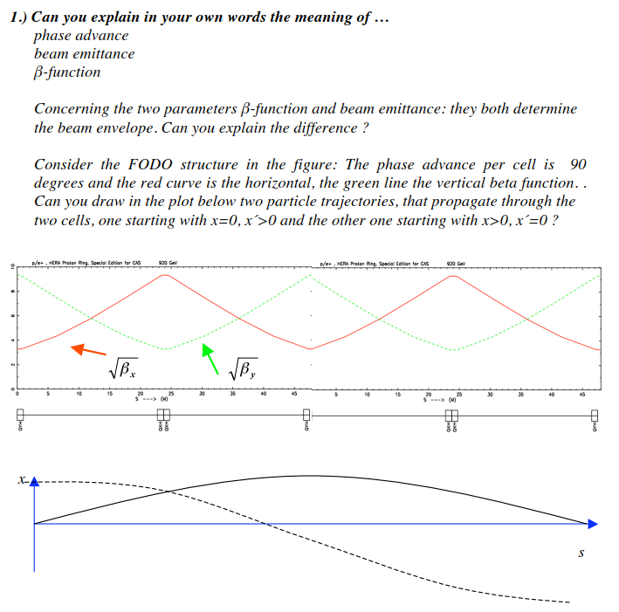

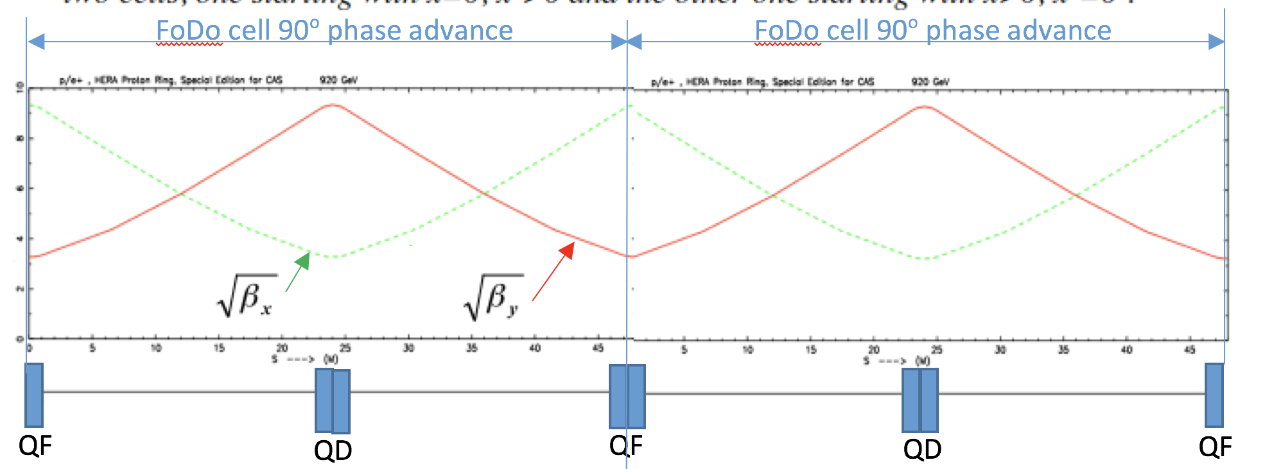

## **2 Phase space ellipses**

Assume somewhere in the storage ring there is a position where α = 0.

Where would such a situation occur typically?

How will the phase space ellipse look like?

Can you give a physical interpretation of the beta function in such place?

Starting from a mini-beta insertion, i.e. alpha = 0, how does the phase space picture develops in the long drift space?

## **3 Apertures and beam envelopes at LHC**

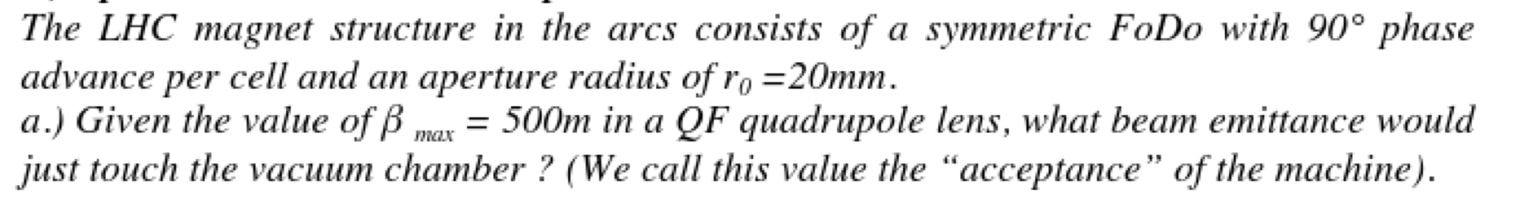





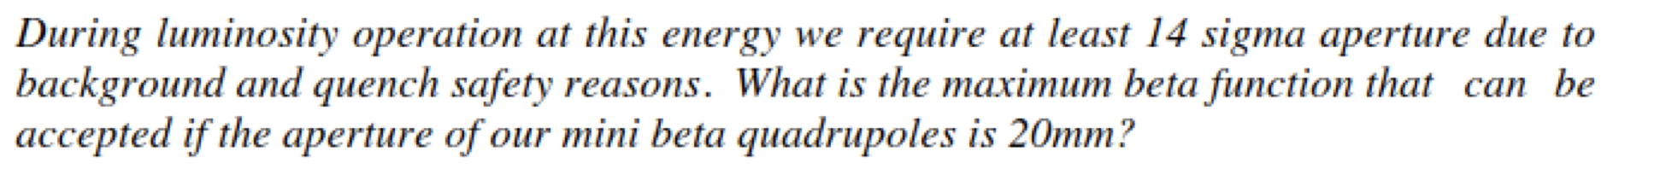

## **4 Apertures and beam envelopes at HERA**

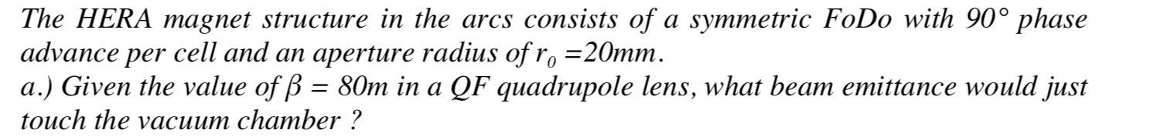



5. In LHC the beam velocity in the s direction is almost the speed of light, could you calculate the beam velocity in the transverse horizontal plane? For this you need to know that the horizontal tune is ~ 64, i.e. every particle does a bit more than 64 complete oscillations in the horizontal plane after one turn. The maximum horizontal offset of the particles around the ideal orbit is 2 mm peak to peak, i.e. ±1 mm, and the time it takes to give one turn is 89 μs.

6. The LHC optics functions are changed from injection (450 GeV) to top energy (7000 GeV). At injection, the beta function in IP1 and IP5 is β*=11 m, in both planes. At top energy and after the squeeze of the beams for luminosity production, the beta function in IP1 and IP5 is β*=0.55 m (for the nominal LHC optics). Why cannot we have a beta function of β*=0.55 m in IP1 and IP5 at injection? To answer the question you need to know that the beta function at the inner triplets (IT) for β*=0.55 m is βIT=4500 m and that the normalize emittance εn=3.5 μm rad (

7. The SPS maximum beta function for LHC beams at the centre of the focusing lattice quadrupoles is βx=108 m (βy=31 m) and the dispersion is Dx=4.5 m (Dy=0 m). Calculate the proton beam size at this position for a εn=3.5 μm rad at injection momentum, 26 GeV/c, and flat top momentum of 450 GeV/c. If we use the same optics for the injection and acceleration of fully stripped lead ions, what is the beam size of the ion beam at the same position? We assume the same relative momentum error for both beams, $\frac{∆p}{p}={10}^{-3}$, and the same normalized emittance.

(In reality the ions are injected at a momentum of 17 GeV/c proton equivalent, and the normalized emittance for ions is εn=3.5 μm rad)

The aperture of a SPS focusing quadrupole is the following:

Aperture_x = 76 mm, Aperture_y=20.75 mm

The aperture of a SPS defocusing quadrupole is the following:

Aperture_x = 41.5 mm, Aperture_y=41.5 mm

Why the aperture for the defocusing quadrupoles is smaller in horizontal ?