Introduction to Particle Accelerators

LONGITUDINAL BEAM DYNAMICS

TUTORIAL 1 QUESTIONS

- Looking at the picture below:
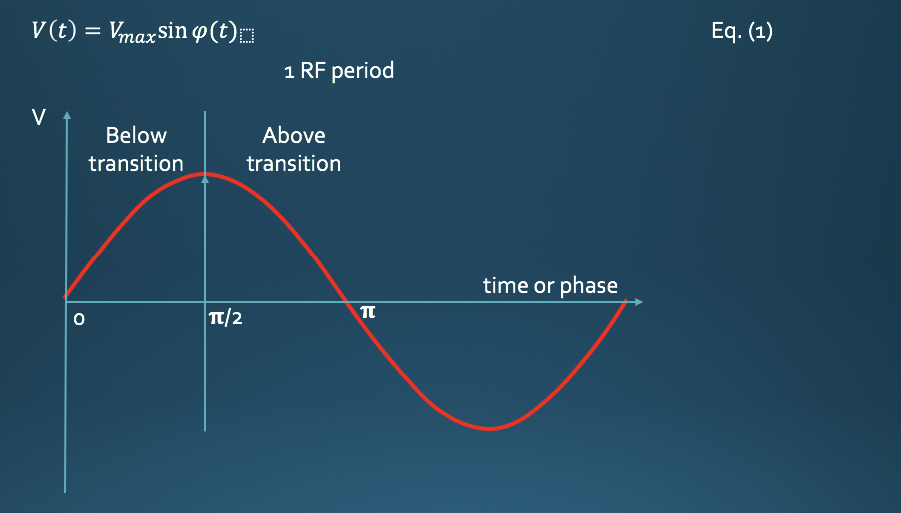
- What should be the synchronous phase for particle acceleration below transition?
- What should be the synchronous phase for acceleration above transition?
- What should be the synchronous phase for keeping the particles at a constant energy below transition?
- What should be the synchronous phase for keeping the particles at a constant energy above transition?
- What are the benefits and limits of using a synchronous phase close to 𝛑/2 during acceleration?
- What are the main differences between leptons and hadron synchrotrons in terms of longitudinal beam dynamics?

- The CERN SPS: The parameters for the CERN SPS (Super Proton Synchrotron) are the following:
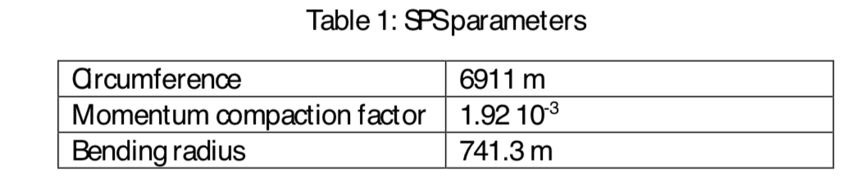
Two types of beam are accelerated in the SPS and the parameters are:
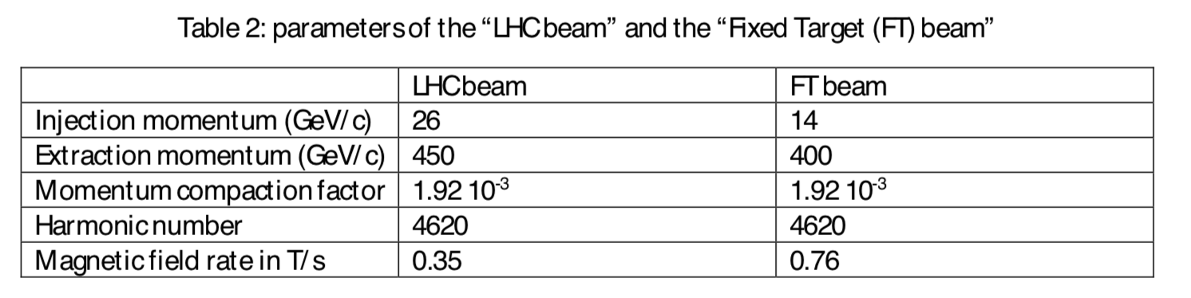
- Define the transition energy in one sentence
- Compute the transition energy for both beams
- Could transition energy be different for the LHC beam and the Fixed Target beam? Which machine optics parameter would need to change?
- Compute the relativistic gamma and slip factor for both beams at injection energy and flat top energy
- Does the LHC beam cross transition?
- Does the FT beam cross transition?
- What needs to be done when transition energy is crossed by a beam?

- At the CERN PS machine the geometrical radius is R = 100 m, and the Bdot = 2.4 T/s (variation of the magnetic field with time during acceleration). The machine has 100 dipoles with an effective length of 4.398 m. The harmonic number is 20. Calculate:
  - The energy gain per turn
  - The minimum RF voltage needed
  - The RF frequency when B = 1.23 T at extraction
- Complete the table below for some CERN machines:
Machine | _{Einj (GeV)} | _{Eflat_top (GeV)} | 𝛄_{tr} | E_{tr} | 𝛂_{c} | 𝛈_{inj} | 𝛈_{flat_top}
LHC | 450 | 7000 | 55.68
SPS | 26 | 450 |  |  | 0.00192
PS | 1.4 | 26 |  |  | 0.027

Exercise 4:
