Introduction to Particle Accelerators

TUTORIAL 2 QUESTIONS

1 LHC: particle momentum, geometry of a storage ring and thin lens calculation
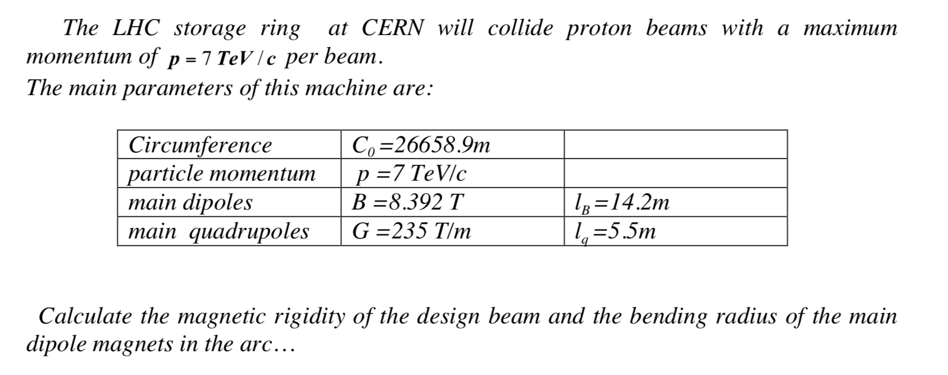

2 A thin quadrupole lens
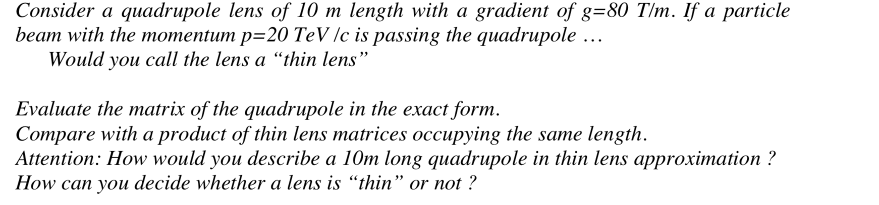

3 A FoDo cell
